The
Philadelphia Eleven
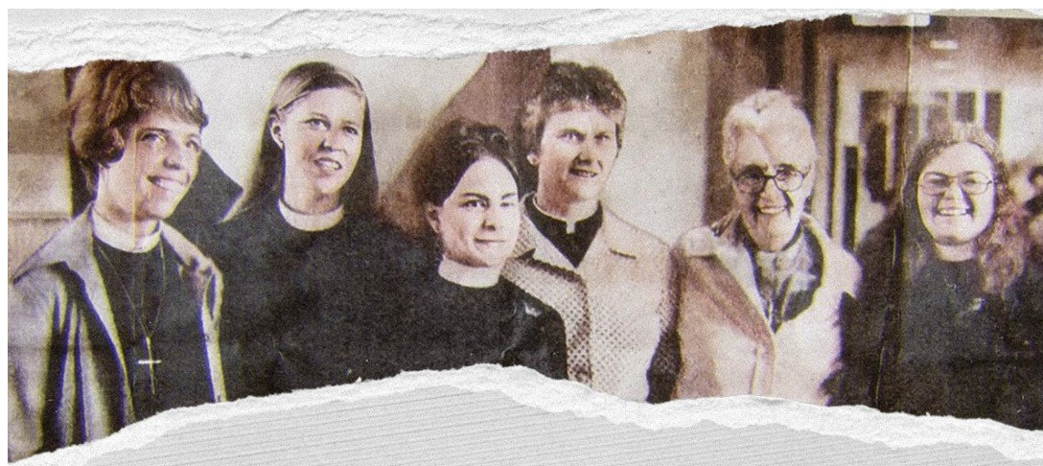
In this feature-length documentary film we meet the eleven women who presented themselves for ordination in the Episcopal Church in 1974, transforming an age-old institution, and challenging the very essence of patriarchy within Christendom.
Sunday, February 4, 3pm
GCSU Arts & Sciences Auditorium
Students FREE with Bobcats card ~ Faculty, Staff, and Community $5
Presented by
Georgia College & State University’s
Episcopal Campus Ministry
Women and Gender Studies
Dept. of Philosophy, Religion, and Liberal Studies
The Honors College

